USN: 2GI19CS014 Student Name: Akhilesh C Sanikop

**Title of the Experiment:** Implementation of parameterized methods and constructors

**Experiment No.**3 **Date:** 24/10/2020

**Problem Statement:**

A certain small bank intends to automate few of its banking operations for its customers.

Design a class by name mybankAccount to store the customer data having following details:

1.accountNumber 2. acctType 3. Name 4. Address 5. accountBalance

The class must have both default and parameterized constructors. Write appropriate method to

compute interest accrued on accountBalance based on accountType and time in years. Assume

5% for S/B account 6.5% for RD account and 7.65 for FD account. Further, add two methods

withdrawAmount/depositAmount with amount as input to withdraw and deposit respectively.

The withdrawAmount method must report insufficient balance if accountBalance falls below Rs. 1000.

TASK 1: Build the class with appropriate member variables, constructors and methods.

TASK 2: Instantiate three objects of above type and perform different operations on the same.

TASK 3: Write a function to display all the three customer details in a tabular form with

appropriate column headings.

**Objectives of the Experiment:**

1. Learn declaration and definition of constructors and methods in Java
2. Learn how to declare objects of a class and access methods
3. Learn how constructors are executed and its different types
4. Understand the use of constructors and methods in a real-life application
5. Learn how to pass parameters to a method and constructors
6. Learn to Display the result in a readable/proper format

**Program Source Code:**

import java.util.*;

class Account{

    int accNo;

    String name,address,accType;

    double balance;

    static int count=0;

    Account(){

        Scanner in= new Scanner(System.in);

        accNo=++count;

        System.out.println("Enter the type of account(SB | FD | RD): ");

        accType=in.nextLine();

        System.out.println("Enter customer name: ");

        name=in.nextLine();

        System.out.println("Enter customer address: ");

        address=in.nextLine();

        System.out.println("Enter Initial Amount: ");

        balance=in.nextDouble();

        in.close();

    }

    Account(String type, String name, String address, double balance){

        accNo=++count;

        accType=type;

        this.name=name;

        this.address=address;

        this.balance=balance;

    }

    void computeInterest(){

        double interest=0;

        switch(accType){

            case "SB" :{

                interest=balance*0.05;

                break;

            }

            case "RD" :{

                interest=balance*0.065;

                break;

            }

            case "FD" :{

                interest=balance*0.0765;

                break;

            }

        }

        System.out.println("Interest Earned: " + interest);

    }

    void withdrawAmount(double amt){

        if(accType.equals("SB")){

            if(balance-amt<1000)

                System.out.println("Denied...Insufficient Balance");

            else

                balance=balance-amt;

        }

        else

            System.out.println("Withdrawal not permitted on these types of account");

        }

    void depositAmount(double amt){

        balance=balance+amt;

    }

    void dispDetails(){

        System.out.println(String.format("%-10s|%-10d|%5s|%-6.2f", name,accNo,accType,balance));

    }

}

public class Bank{

    public static void main(String[] args){

        Account a1= new Account("SB","Akhilesh","R C Nagar Belagavi",17596.51);

        Account a2= new Account("FD","Rahul","Mandoli Road Belagavi",25987.69);

        Account a3= new Account("RD","Sanyukta","Bhagyanagar Belagavi",15340.96);

        System.out.println(String.format("%-10s|%-10s|%5s|%-6s", "Name","AccNumber","Type","Balance"));

        a1.dispDetails();

        a2.dispDetails();

        a3.dispDetails();

        Scanner in= new Scanner(System.in);

        Account a4= new Account();

        a4.computeInterest();

        double amnt;

        System.out.println("Enter the amount to be deposited: ");

        amnt=in.nextDouble();

        a4.depositAmount(amnt);

        System.out.println("Enter the amount to be withdrawn: ");

        amnt=in.nextDouble();

        a4.withdrawAmount(amnt);

        System.out.println(String.format("%-10s|%-10s|%5s|%-6s", "Name","AccNumber","Type","Balance"));

        a4.dispDetails();

        in.close();

    }

}

**OUTPUT:**

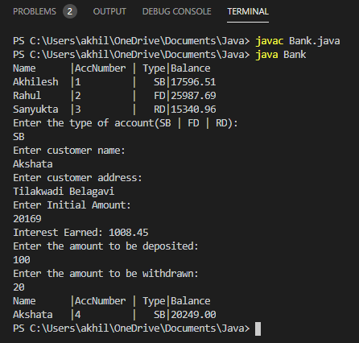 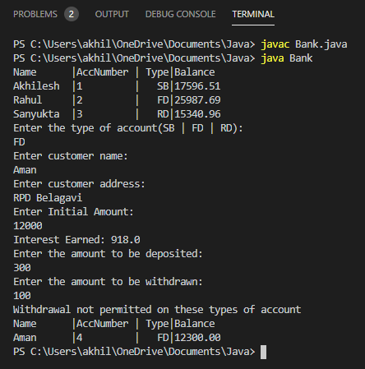

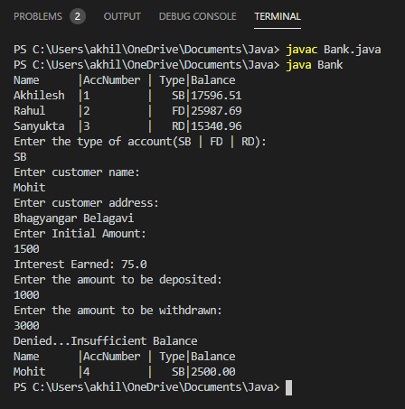

**Outcomes of the Experiment:** At the end of the laboratory sessions the students should be able to

1. Demonstrate the use of constructors and methods in solving real-life problems.
2. Identify when to use methods and when to use constructors
3. Identify appropriate method or constructor to be used for a particular scenario
4. Learn how to return values from a method
5. Differentiate between default and parameterized constructors
6. Identify how to make a call for the method

**Conclusions:**  From the given problem statement, we could identify the necessary variables and use the appropriate constructors and methods and the necessary program logic. We understood how the banking system works and the way in which transactions are handled. The program was written in Visual Studio Code by creating a project. We understood the usage of the IDE in typing the code, debugging, running the program and observing the output. We also understood the use of the built-in class System and its method println to display the result. The program was executed for two-three sets of input and results obtained were verified to be correct and recorded.

**PRACTICE PROBLEM**

Define a class to represent a rectangle in which constructors and parameterized methods are

used. It also has a method to compute area of rectangle.

i. First make a class rectangle in which we declare the parameterized constructor.

ii. Then demonstrate the use of parameterized method.

iii. Use a method to compute area of rectangle.

iv. Create a class to demonstrate the call of the methods in previously created class rectangle

holding constructors, parameterized methods and method to compute area of rectangle.

**Program Source Code:**

import java.util.Scanner;

class MyRectangle{

    int length,breadth;

    MyRectangle(int l,int b){

        length=l;

        breadth=b;

    }

    MyRectangle(){

        //initialize an object

    }

    void changeDim(int length,int breadth) {

        this.length=length;

        this.breadth=breadth;

    }

    int area() {

        return length*breadth;

    }

}

public class AreaRect {

    public static void main(String[] args) {

        MyRectangle r1=new MyRectangle(20,40);

        System.out.println("Area of rectangle for object r1 :"+r1.area()+" sq. units"

);

        Scanner s=new Scanner(System.in);

        MyRectangle r2=new MyRectangle();

        System.out.println("Enter the length and breadth for rectangle: ");

        int length=s.nextInt();

        int breadth=s.nextInt();

        r2.changeDim(length, breadth);

        System.out.println("Area of rectangle for object r2 :"+r2.area()+" sq. units"

);

        s.close();

    }

}

**OUTPUT:**

